**Types of Synovial Joints Labeling**

**Activity**

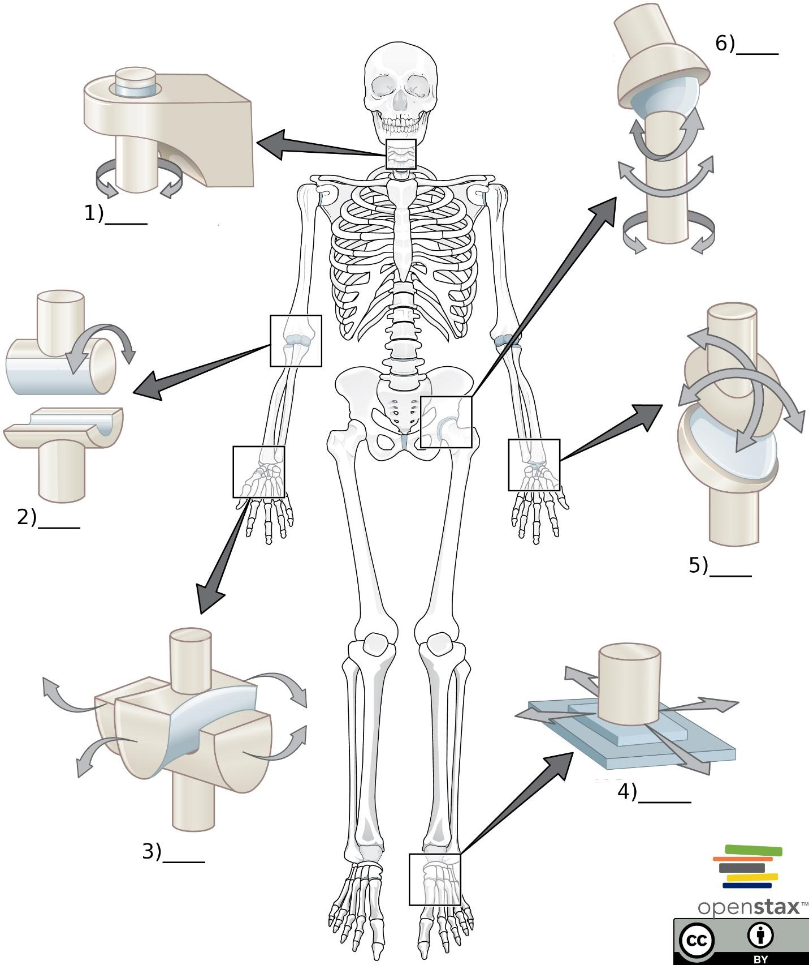

# Word Bank

1. Plane joint (Between tarsal bones)
2. Hinge joint (elbow)
3. Pivot joint (between C1 & C2 vertebrae)
4. Saddle joint (between trapezium carpal bone & 1st metacarpal bone)
5. Plane joint (between tarsal bones)
6. Condyloid joint (between radius & carpal bones of the wrist)
7. Ball-and-socket joint (Hip Joint)

# Answer Key

1. c) Pivot joint (between C1 & C2 vertebrae)
2. b) Hinge joint (elbow)
3. d) Saddle joint (between trapezium carpal bone & 1st metacarpal bone)
4. e) Plane joint (between tarsal bones)
5. f) Condyloid joint (between radius & carpal bones of the wrist)
6. g) Ball-and-socket joint (Hip Joint)